APPLICATION TO BECOME A PATRON OF TCS

CAPITAL LETTERS PLEASE

Name______________________________________ Date________________________

Address_________________________________________________

_____________________________________Post code___________________

Email ____________________________________________________

I wish to become a PATRON OF TEWKESBURY CHORAL SOCIETY

by contributing £________annually by Cheque/Bank transfer (please show).

(For bank transfer: Tewkesbury Choral Society, a business account, sort code 30-91-87 acc 03028035.)

Please notify me of all concerts and events held by Society which I may attend, and include my name on the published list of Patrons.

Minimum contribution - £60 per annum

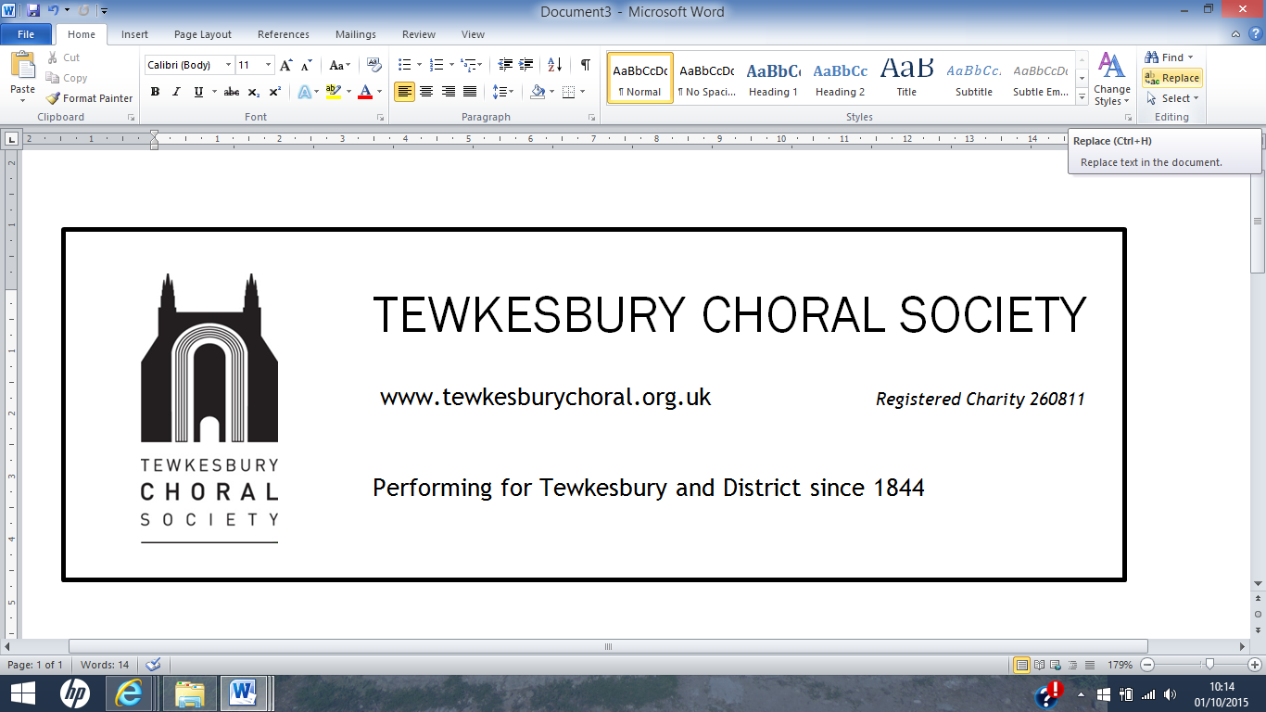 | Gift  Aid  Donations
The Society is able to claim back tax that you have already paid to the Treasury on Patron donations, excluding the value of any discount on, or complementary, tickets supplied, if you fill out this simple form. Boost by 25p of Gift Aid for every £1 donated. Gift Aid is reclaimed by the charity from the tax you pay for the current tax year. Your address is needed to identify you as a current UK taxpayer.
In order to Gift Aid your donation you must tick box:

To tick box on line, copy and paste

I want to Gift Aid my Patron donation (excluding discounts & value of complementary tickets) and any donations I make in the future or have made in the past 4 years to Tewkesbury Choral Society. I am a UK taxpayer and understand that, if I pay less Income Tax and/or Capital Gains Tax than the amount of Gift Aid claimed on all my donations in that tax year, it is my responsibility to pay any difference.
My Details Title _______ First name or initial(s) _______________Surname _______________
House number/name ____________Postcode ____________ Date ______________________
Please inform the Treasurer if you want to cancel this declaration; change your name or home address; no longer pay sufficient tax on your income and/or capital gains. If you pay Income Tax at the higher or additional rate and want to receive the additional tax relief due to you, you must include all your Gift Aid donations on your Self-Assessment tax return or ask HM Revenue and Customs to adjust your tax code.

