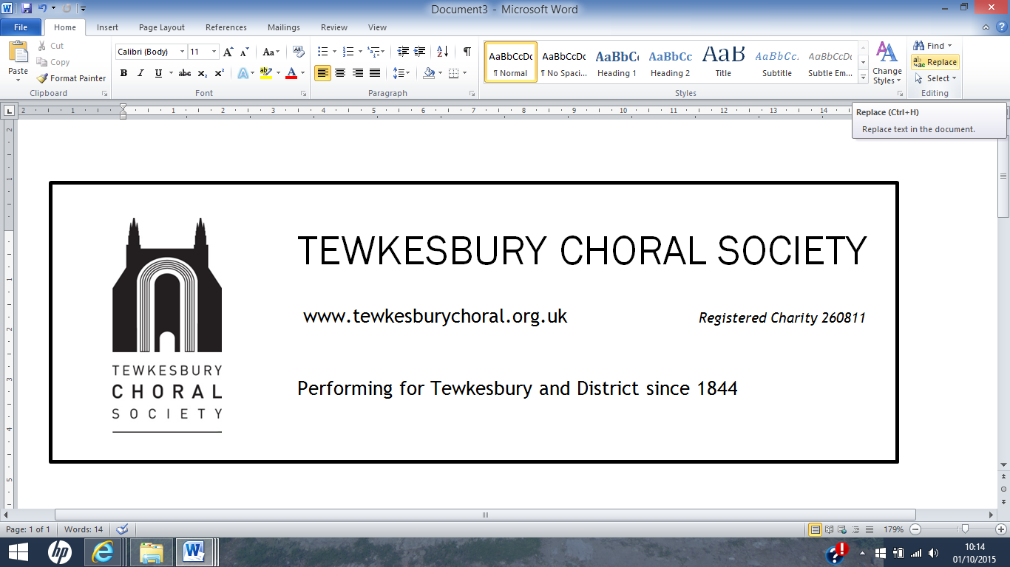 | Gift  Aid  Donations
The Society is able to claim back tax that you have already paid to the Treasury if you fill out this simple form. Boost by 25p of Gift Aid for every £1 donated. Gift Aid is reclaimed by the charity from the tax you pay for the current tax year. Your address is needed to identify you as a current UK taxpayer.
In order to Gift Aid your donation you must tick the box:

To tick box, copy and paste

I want to Gift Aid my subscription and any donations I make in the future or have made in the past 4 years to Tewkesbury Choral Society. I am a UK taxpayer and understand that, if I pay less Income Tax and/or Capital Gains Tax than the amount of Gift Aid claimed on all my donations in that tax year, it is my responsibility to pay any difference.

My Details Title _______ First name or initial(s) _______________Surname _______________

House number/name ________________

Postcode __________________________ Date ___________________________________

Please inform the Treasurer if you:
want to cancel this declaration;
change your name or home address;
no longer pay sufficient tax on your income and/or capital gains.
If you pay Income Tax at the higher or additional rate and want to receive the additional tax relief due to you, you must include all your Gift Aid donations on your Self-Assessment tax return or ask HM Revenue and Customs to adjust your tax code.

